BITS Pilani, Dubai Campus

Dubai International Academic City, Dubai

I Semester 2020-21

CS F222 Discrete Structures for Computer Science

Assignment - I

ID No: 2019A7PS0020U

Name: Dhruv Maheshwari

Section No: 2

Ques No: 21

Ques Statement: Given a graph and a positive integer n, write a program to determine whether the graph has a cycle of length n.

Input:

Given below are graphs and their adjacency matrices.

Example 1:

|  |  |  |  |  |  |
| --- | --- | --- | --- | --- | --- |
|  | a | b | c | d | e |
| a | 0 | 1 | 0 | 0 | 1 |
| b | 1 | 0 | 1 | 1 | 1 |
| c | 0 | 1 | 0 | 1 | 0 |
| d | 0 | 1 | 1 | 0 | 1 |
| e | 1 | 1 | 0 | 1 | 0 |

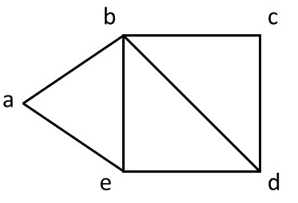

Example 2

|  |  |  |  |  |  |  |
| --- | --- | --- | --- | --- | --- | --- |
|  | a | b | c | d | e | f |
| a | 0 | 1 | 1 | 0 | 0 | 1 |
| b | 1 | 0 | 1 | 0 | 0 | 0 |
| c | 1 | 1 | 0 | 1 | 0 | 1 |
| d | 0 | 0 | 1 | 0 | 1 | 1 |
| e | 0 | 0 | 0 | 1 | 0 | 1 |
| f | 1 | 0 | 1 | 1 | 1 | 0 |

